Abstract

Negative sleep behaviors range from benign problems like snoring to more severe problems like sleep apnea and insomnia. On an individual-level they may cause discomfort and longer term physiological problems, and on a macro-level there exist greater implications for healthcare costs and worker productivity levels. Our research aims to address two challenges in the field of sleep-tech: 1) creating a non-invasive sleep-tracking device and 2) designing a real-time feedback system that accommodates to individuals’ unique sleeping behaviors and preferences. We present a prototype smart pillow that collects and classifies user sleeping data based on their head angle and sleeping position with an average accuracy of 97.3 percent, and we also offer preliminary results of a non-invasive, closed-loop recommendation system using our smart pillow and a recommendation architecture developed by SleepCoacher (Daskalova et. al). We find that collecting data in real-time with a tool that is already used in sleeping environments allows for a more nuanced understanding of sleeping patterns throughout the night, and leads to more relevant recommendations on improving sleep quality over time. We conclude that further refinements and additional features to the pillow and recommendation system will allow for a learning system that actively assists users in improving their sleep quality.

Introduction

The act of sleeping contributes not only to an individual’s own quality of life but also to the greater societal well-being. On a case-by-case basis, a lack of sleep has been shown to negatively impact an individual’s physical and emotional health[1], and on a macro level, the resulting irritability, tiredness, and impaired concentration that arise from a lack of quality sleep can both impact productivity levels and increase the number of public accidents (i.e. traffic accidents, operating / factory accidents, etc.)[2].

In addition to the impact of sleep on other functioning areas, the causes of poor sleep range from benign problems like snoring to more severe problems like sleep apnea. The wide range of sleep problems paired with individuals’ unique sleeping preferences and behaviors introduce a need for tailored diagnoses and treatments for individual patients.

While current solutions for sleep problems focus on diagnosis and follow-up treatment, both the former and latter skew towards the expensive end; for example, sleep apnea is most commonly detected using polysomnography, during which the patient is required to sleep in a specialized sleep center while their physiological signals are recorded and analyzed by professional staff. However, this method is both time-consuming, intrusive, and expensive, and such characteristics act as obstacles towards sleep apnea patients even beginning to get diagnosed, let alone treated for their symptoms.

Recently, more attention has been given to non-invasive sleep-data collecting tools and closed loop feedback systems. Real-time, auto-adjustable systems that detect and actively address specific sleep conditions reduce the cost of diagnosis and treatment for some sleep issues but struggle to scale with the growing number of sleep problems that individuals may face[3]. Closed-loop systems that generate data-driven sleep recommendations based on sleep behavior and users’ self-observed problems are able to encompass a wider range of sleep issues but place the burden of executing sleep recommendations on individuals. More specifically, sleeping individuals may not always have the physical and mental capacity to modify their behavior according to the generated recommendations.

Our work explores if and how a non-invasive, closed-loop feedback system of data collection and recommendation generation impacts an individual’s sleep quality. We design an inexpensive prototype smart pillow that continuously collects orientation, angular rotation and acceleration, noise, and head location data. We develop a voice-activated calibration system to build an individually-tailored classification model that detects four different sleeping positions with up to 97.2 percent accuracy. We conduct 8 overnight user tests, during which we track a subject’s sleeping behavior throughout the night, and we use the collected data along with their supplied feedback to generate recommendations on their sleep behavior for the following night.

Our results show that subjects deem our smart pillow to be equal in comfort to any other pillow that they normally use, and more preferable to any invasive form factor (i.e. smartphone, clinic) that might be used to collect and analyze sleep data, ceteris paribus. Additionally, our synthesis of subjects’ sleep data and their own provided post-sleeping problems provided actionable recommendations in the best case, and an insightful look into their sleep patterns in the worst case.

In our work, we offer two primary contributions: 1) a voice-activated sleep-data collecting pillow that is economic in construction and comfortably integrated into the user’s sleeping environment, and 2) the initial architecture of a closed-feedback, active recommendation system that can make educated diagnoses and recommendations on sleep behavior.

Related Work

Methods surrounding sleep-data collection have evolved as technology becomes faster, cheaper, and more accessible. Polysomnography (PSG), one of the earlier forms of professional sleep monitoring, is used to detect sleep disorders and requires that patients sleep overnight in a hospital or sleep clinic, away from the comfort of their regular sleeping environments. In addition to the change in environment and placement of electrodes on the scalp, eyelids, and chin, a PSG can also be extremely costly (ranging to thousands of dollars). The sleep monitoring system, while effective, can prove to be obtrusive for its many setup requirements and inaccessible for its cost[4]. In our work, we strive to emulate the sleep-data collection process while preserving patients’ desire for privacy and economy.

Newer methods strive to reduce the cost of sleep-tracking while also reducing the amount of setup required in actual sleep-data collection devices. Recently, smartphones have increasingly been used as sleep-tracking devices for their portability and general market penetration of the greater population. They can perform passive functions including sleep tracking, audio environment monitoring, identification of snoring and sleep-talking, and sleep latency, among other parameters[5]. While the collection of such data can be used to guide further evaluation and treatment, it is not as common for a smartphone app to assist individuals in modifying and directly treating their sleep behaviors. SleepCoacher[6] is one of the first methods that makes use of a closed-loop recommendation system, by providing a framework for guiding users through personalized micro-experiments, observing the impact of data-driven, pre-sleep recommendations over time and improving on them iteratively. It was observed that participant sleep quality improves as adherence to SleepCoacher’s recommendations increases, indicating that new methods to more effectively integrate such a sleep-tracking and feedback system into an individual’s sleeping environment and assist individuals in adhering to data-driven sleep recommendations are necessary in situations where individuals cannot directly help themselves (i.e. when they are sleeping). Our research builds upon SleepCoacher’s system by introducing during-sleep recommendations; sleep research indicates that there exist causal relationships between the way an individual sleeps at night and the physical pains they experience the morning after[7], and we hypothesize that recommendations based on ways an individual can modify their specific sleep behavior can improve their future sleep quality. Additionally, we use our work as a preliminary example of non-invasive, ubiquitous computing in a private household environment; rather than reserving computations and computer science for specific devices, we relocate our data collection from outside of a smartphone to inside of an inanimate pillow.

Because individual sleep patterns and sleep preferences are unique, during-sleep recommendations must also be tailored to the individual. However, because it is difficult for individuals to actively change their behavior when they are in a passive sleeping state, there appears to be a need for more active closed-feedback recommendation systems. More specifically, a system that can assist not only in making recommendations but also reinforcing an individual’s adherence to that recommendation, should they choose to follow it. New research in hardware and smart materials has given rise to the idea of personal fabrication for regularly inanimate or passive objects, which we elaborate on in our Future Work and Discussion section[8].

SYSTEM DESIGN

The initial goal we set for our system is to be able to collect data such that we can identify an individual’s current sleeping position (i.e. back, left, right, stomach). Additionally, we prioritized solutions and iterations that were more cost-effective and non-invasive in a conventional sleeping environment (i.e. bedroom), such that we could create a data-collection and feedback system that could be used and accessed just as easily by an individual at home as it could be by a researcher in a laboratory setting. Our prioritizations in pillow design frequently led us to encounter the tradeoff of using higher accuracy hardware versus exploring cost-effective, more creative solutions. We designed the final system in two separate portions: 1) Sleep data collection through a smart pillow and 2) data analysis and providing behavioral recommendations based on collected sleep data and self-volunteered user input.

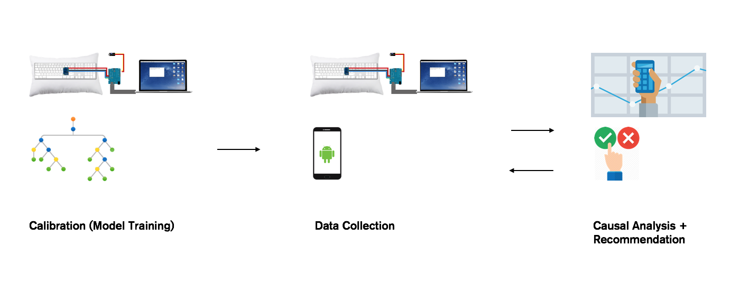

Sleep Data Collection – Hardware

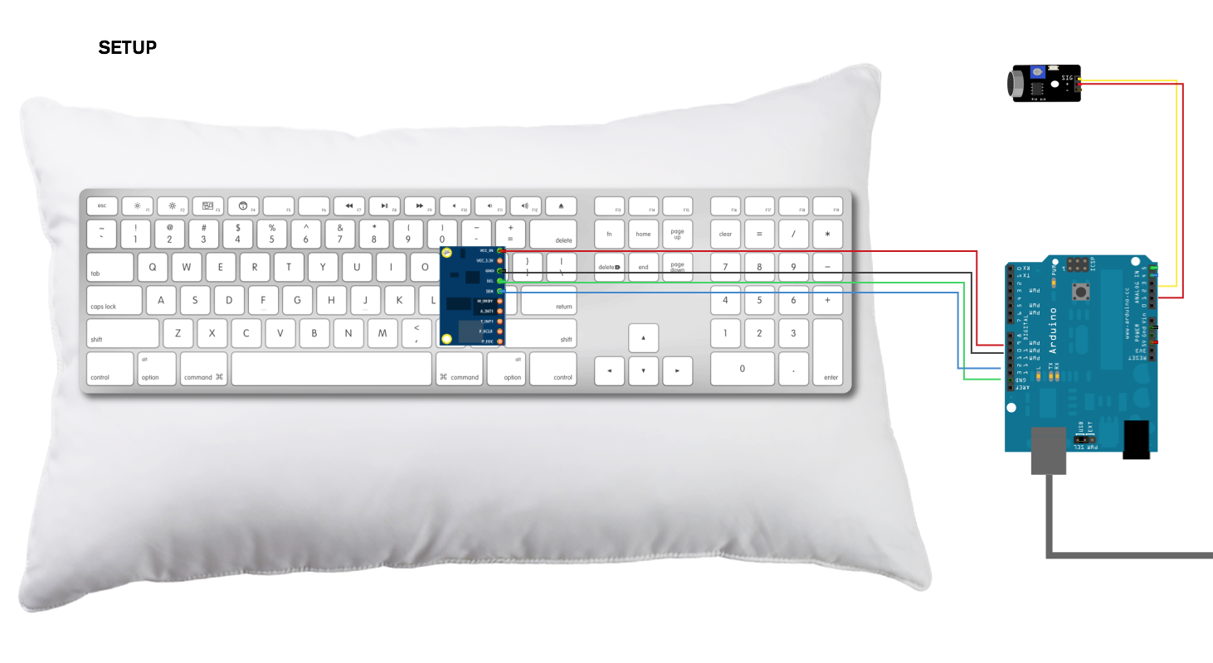

The pillow that we use as the base for our smart pillow was purchased from Amazon and is a 100% Cotton Hotel Down-Alternative pillow encased in a 400 Thread Count Cotton Hemstich pillowcase. We choose these specific products for their high customer rating and cost.

The smart pillow hardware consists of several different parts: an Arduino Uno, an Adafruit 9DOF IMU Breakout Board, an Adafruit Microphone Amplifier Breakout Board, and an Apple Magic Keyboard.

We choose the Adafruit 9DOF for its cost effectiveness and ability to collect orientation and accelerometer data. Specifically, we cut a slit into the top edge of the pillow and place the Adafruit 9DOF at the center of the pillow, such that the X axis runs perpendicular to the top plane of the pillow, the Y axis runs vertically and parallel to the top plane of the pillow, and the Z axis runs horizontally and parallel to the top plane of the pillow. While other iterations examined the idea of placing two accelerometers at opposite ends of the pillow, or four accelerometers at each corner of the pillow for hypothesized higher accuracy, we decided to place a single accelerometer at the center of the pillow as an inexpensive initial proof of concept for detecting sleeping position.

We choose the Adafruit Microphone for its cost effectiveness and ability to pick up noises in the environment, and place it outside of the pillow in order to avoid picking up extra noise that might be sensed by the microphone rubbing against the pillow cotton, if it were placed internally. We keep the microphone located towards the top edge of the pillow and away from where an individual would typically place their head and body, so as to allow for greater comfort and sleeping mobility.

Finally, we use an Apple Magic Keyboard as a means of detecting head position on our smart pillow. While we ideally would have been able to use a pressure grid, we were limited by budget constraints, and a standard pressure grid, let alone a grid customized specifically for our purposes, would have proven too expensive. As a result, we detect head location on a pillow based on what keys on the keyboard are pressed at any given point in time, also ensuring that the keyboard is strong enough to withstand the entire weight of the smart pillow and pillowcase itself without any of its keys being pressed. We place the keyboard between the bottom of the pillow and the pillowcase, and to prevent the keyboard from moving around, we sew a cloth pocket into the inside of the pillowcase such that the keyboard can easily be slipped in and out of the pillow.

We connect our Adafruit 9DOF and Adafruit Microphone to an Arduino Uno, which collects our desired orientation and microphone data and sends it all via serial port to a Macbook Pro (Retina, 13-inch, Early 2015) with 2.7 GHz Intel Core i5. The Apple Magic Keyboard is directly connected to the Macbook Pro and sends a binary array of all keys on the keyboard, using a 1 to indicate a keypress and 0 to indicate an unpressed key.

Sleep Data Collection – Reading Data

Once accelerometer, gyroscope, microphone, and keyboard data is transmitted to the computer, we use a simple Python script to write the features as a single datapoint row in a CSV file, reading approximately two datapoints every second. While we can certainly read more or fewer datapoints per second, we decide on two in order to preserve accuracy while limiting the amount of noise.

Sleep Data Collection – Calibration

In order to collect datapoints with ground truth (i.e. data during which we know an individual is in a specific sleeping position), we create a voice activated interface that guides an individual through several sleeping poses. We use the Google Cloud Voice Recognition API to constantly take in microphone data; when it is detected that an individual has said “Hey pillow, recalibrate”, the system prompts the individual to move into a specific sleeping pose for several seconds, before prompting them to move into a new pose, and so on. Specifically, our voice interface guides users through the sleeping position cycle of lying on their right side, their back, their left side, and their stomach. We have them lie in each position for approximately 20 seconds, and we have them go through the entire cycle twice in order to account for variations in the same sleeping position.

Data Analysis – Model Building & Classification

After collecting our initial calibration data, we train several different models and evaluate their classification accuracy in order to determine which model we should ultimately use when classifying new sleep data. We use the Python library SciKit-Learn to construct a naïve Bayes classifier, Stochastic Gradient Descent (SGD) classifier, Support Vector Machine (SVM) classifier, and decision trees. Each classifier is trained using 80 percent of our ground truth data and tested with 20 percent of our ground truth data. We present our accuracy findings in the Results section, but conclude that a decision tree yields the highest classification accuracy in determining sleeping position. As a result, moving forward we use a decision tree as our smart pillow classification model.

New sleep data that is collected overnight is fed into the trained decision tree in order to associate a sleeping position for each individual datapoint. Using timestamps associated with each datapoint, we then calculate the time at which an individual moved into that sleeping position and the duration for which they stayed in that position.

Data Analysis – Recommendation

We send our data to SleepCoacher’s servers and run SleepCoacher’s sleep analysis algorithms on the collected accelerometer data to determine the time an individual went to sleep, the time it took for them to fall asleep, and the duration that they were asleep for. Additionally, we collect feedback from individuals on their own perceived sleep quality using SleepCoacher’s followup survey asking about their level of tiredness and any other problems they may be experiencing.

For individuals who have not gathered enough datapoints across different nights (thus running any statistical tests wouldn’t yield much significance), we make educated recommendations on how they can change their sleep behavior based on published sleep research. For those individuals who have slept on the smart pillow for multiple nights, we attempt to find correlations between their sleeping positions and rated quality of sleep in order to provide recommendations on how they can continue to improve their sleep quality moving forward.

System Limitations

We acknowledge that while ideally our smart pillow system will accommodate for different handling use cases (i.e. person sleeping on it normally, person hugging it, person folding it, etc.) in the future, our current hardware setup (especially a rigid keyboard) and our prioritization of a cost-effective prototype for proof-of-concept prevent us from being able to explore these behaviors at the present. The initial prototype is only meant to be slept on as a standard pillow supporting a single individual’s head.

Implementation Details

All scripts for collecting data, training and validating models, and sending data to a remote server were written in Python3 and are easily executable from any command line interface. Approximately 400 lines of code were written.

USER TESTING

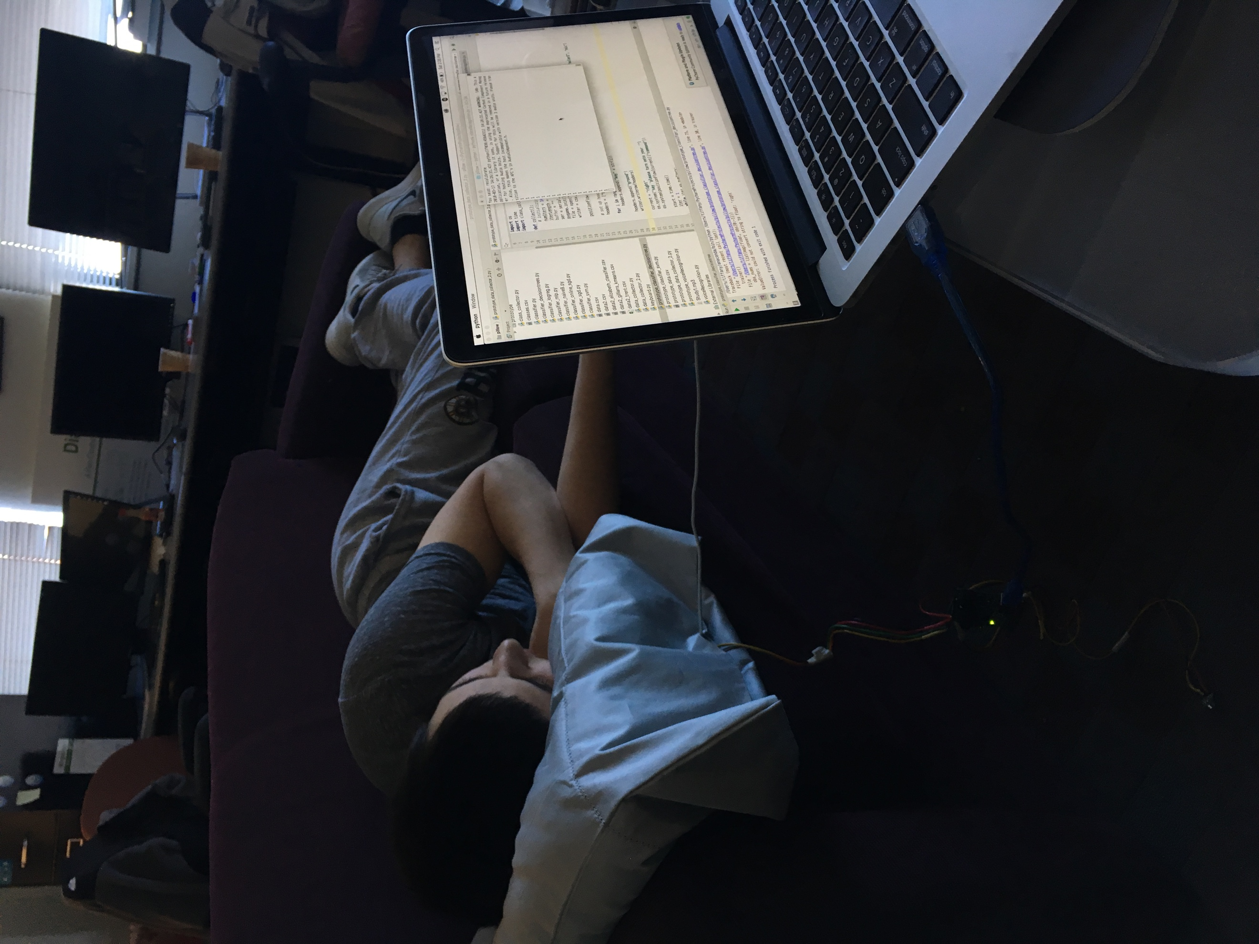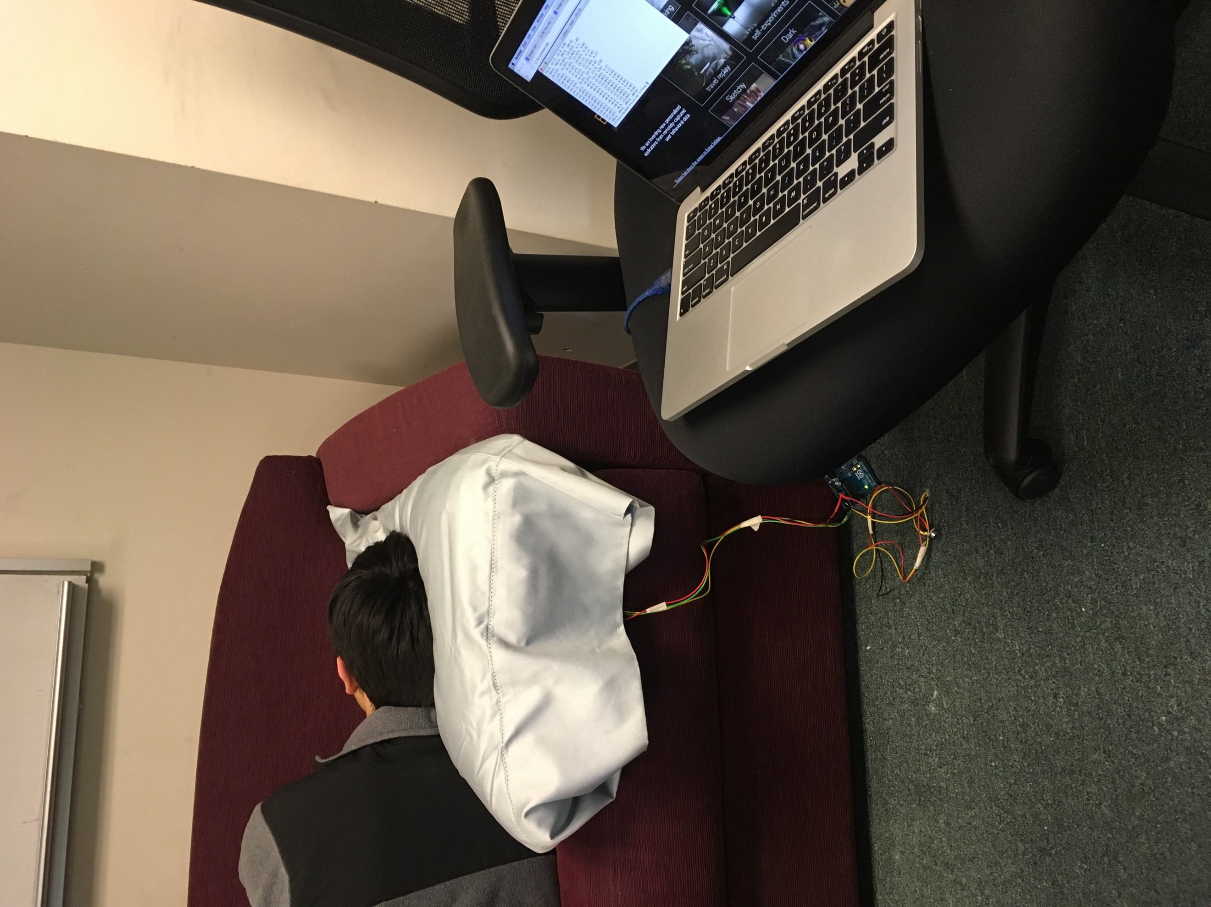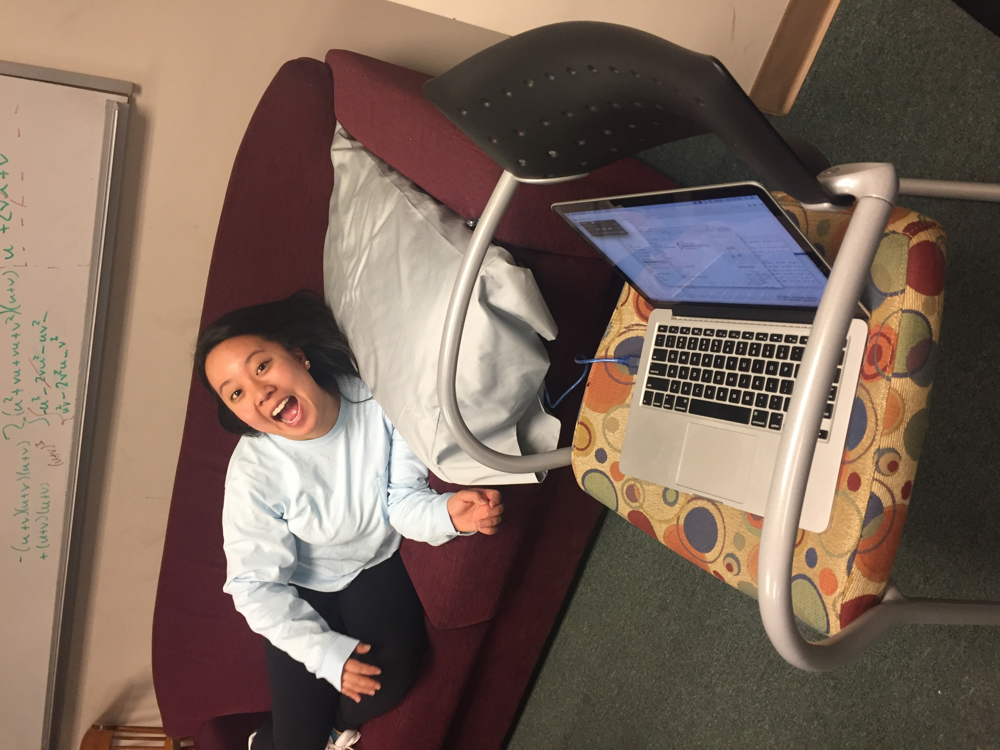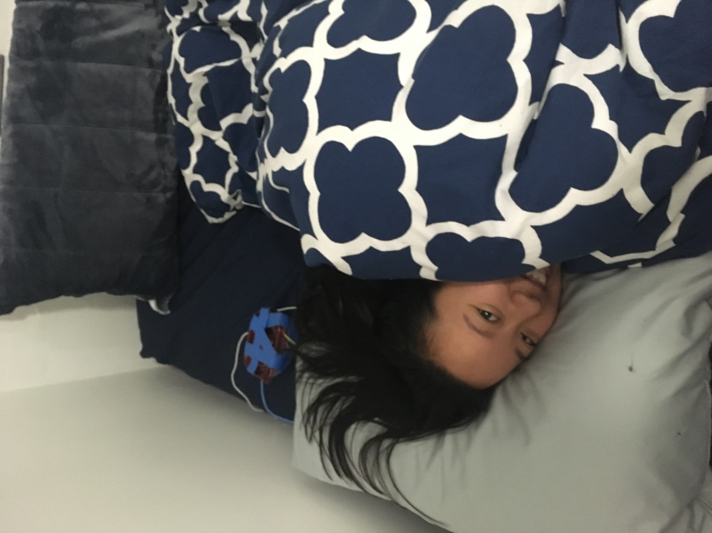

Pillow testing

We first gathered qualitative feedback on the initial pillow prototype, specifically looking for user input on the smart pillow’s physical comfortability and discernibility from a regular pillow. We also wanted to understand whether users would prefer such a smart pillow that collected and interpreted sleep data to a smartphone that performed identical functions.

We recruited 11 subjects from around the university campus. Of the 11, four identified as female and seven identified as male. The mean age was 24 years with a standard deviation of 3.9 years.

To conduct user testing, we first lay the smart pillow on a horizontal, cushioned surface (either a bed or a couch). Without informing the subject of the smart pillow’s inner hardware contents, we ask them to lie down on the pillow and tell us about their level of comfortability. After they have shared their thoughts, we inform them of the smart pillow’s capabilities (including the recommendation system) and ask subjects to tell us about their preferences between an integrated smart device versus a more obtrusive one, like a smartphone when it comes to collecting personal sleep data.

System testing

We next wanted to evaluate the efficacy of our non-intrusive, closed-loop recommendation system in improving sleep quality. We recruited three subjects from around the university campus (two female and one male) of mean age 21.7 years and standard deviation 0.5 years to utilize our sleep recommendation system overnight.

Participants were asked to sleep as they normally did in their preferred sleeping environment, but substituting out their normal pillow that they lay their heads on for our smart pillow. Prior to sleeping, they were first asked to calibrate the smart pillow to their unique sleeping positions. Afterwards, they were asked to run SleepCoacher on their smartphone (placed on their bed) overnight while also sleeping on the smart pillow. On waking up the next morning, subjects would simply pause sleep data collection from both the smart pillow and SleepCoacher and they would answer several questions pertaining to their sleep quality.

Given time constraints for the research, two participants were asked to use the system for a single night while another participant was asked to use the system for several days.

RESULTS

We divide our results into several different portions, according to the relevant part of the closed-loop recommendation system.

Smart pillow prototype results

None of the 11 subjects were able to detect the hardware inside the pillow simply from placing their heads on it; it was only when they placed their hands underneath the smart pillow that they felt the rigid keyboard and realized the extent to which there was hardware embedded inside the pillow. Additionally, the smart pillow was described as “comfy” and “similar to other pillows” that subjects used during their normal sleep routines.

When asked to compare a smart pillow that could collect an individual’s sleep data to a smart phone device that performed identical functionality, 10 out of 11 subjects said that they would prefer a that smart pillow collect their data over a smartphone, all else equal. While one subject advocated for a smart pillow by saying “Comfort wise, I would prefer a smart pillow… as opposed to a phone that may or may not be producing the effects I want”, another subject strongly preferred a smartphone to a smart pillow and noted, “I’d rather use an app on my phone, that way I can get any pillow I want. I don’t want to be forced to use a pillow that isn’t comfortable”.

Classification Model Results

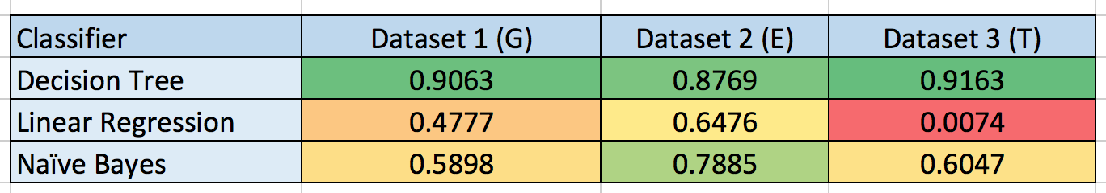

In searching for the best classification model to use in our closed-loop recommendation system, we use our ground truth data to train and validate several different models. It can be observed that using a decision tree offered significantly higher accuracy over other commonly used classification models when categorizing several different sets of ground truth data.

Using the decision tree model to calibrate 10 different ground truth datasets, we found that the accuracy of the decision tree ranged between 89.0 and 97.3 percent accuracy, with an average accuracy of 95.4 percent.

While we did not have the proper equipment or budget to be able to classify our data using polysomnography, we recruited a local university student majoring in Computer Science and Economics to examine the sleep data by hand and attempt to categorize individual data points using the four provided data categorizations (left, back, right, stomach). We find that, even when using a human as a baseline for the minimum classification accuracy we hope to achieve, our decision tree model outperforms the baseline by approximately 20 percent.

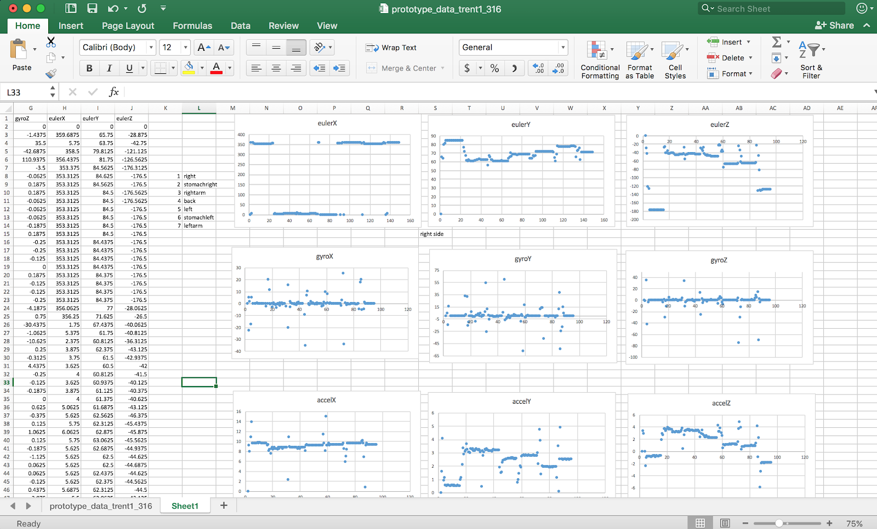

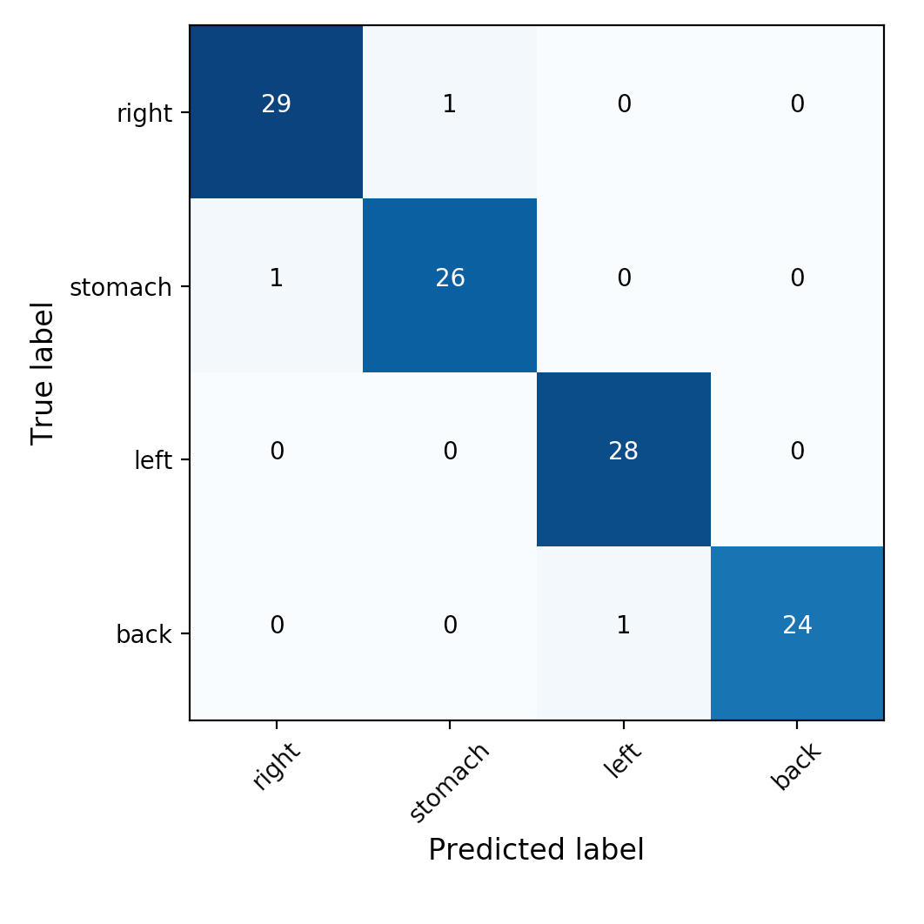 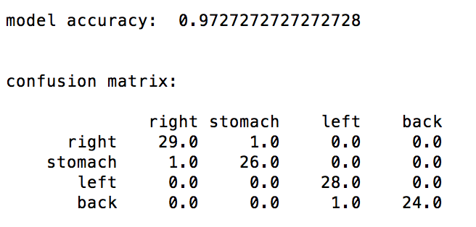

Analysis / Recommendation results

For our first subject, it was observed from the smart pillow’s collected sleep data that they spent the first half of their night sleeping on their right side before turning over to sleep on their left side for the last half of the night. They noted waking up feeling well-rested, and that the fact that they had substituted their normal pillow for our smart pillow did not seem to have impacted their quality of sleep.

For our second subject, it was observed from the smart pillow’s collected sleep data that they spent the majority of their night lying on stomach. Collected observations from our second subject also noted that they experienced some uncomfortable neck stiffness upon waking up the next day.

For our third subject, it was observed from the smart pillow’s collected sleep data that they spent their first night alternating between sleeping on their right side and sleeping on their back, which was corroborated by their separately self-observed sleeping behavior during the night. Additionally, the subject had only slept for a total of four hours and reported feeling rather tired upon waking up the next morning. The recommendation __

DISCUSSION

Much research has been done on the relation between sleeping position and physical impact on the human body. That being said, it was surprising how pains and stiffness that were reported in specific areas of the body were always accompanied by the pattern of sleeping positions that are most frequently associated with such physical pains. As a result, this goes to show that sleep monitoring no longer has to be conducted in strange environments – but, perhaps just as importantly, it does not have to impede on an individual’s privacy the way that a video camera set up to record someone through the night might do so. Rather, sleep data tracking devices can easily make use of already existing sleep research statistics in order to help target the original behavioral causes of an individual’s sleeping problems.

On a more individualized level, we observed firsthand that individuals’ sleeping patterns and preferences were extremely unique. As a result, we could see that individuals experiencing the same sleep problem might not always receive the same behavior change recommendation, if their sleeping behaviors were very different. In this sense, being able to develop a pipeline that could accommodate to all individuals in a tailored manner resulted in a much more tailored and effective recommendation system to improve sleep quality.

The overwhelming preference for a smart pillow over a smart phone that collects data also sheds light into future integration of computational technology and personal informatics devices in private spaces; even with similar hardware and technology, preference for technology embedded into an already existing part of the environment indicates that the form factor with which we deliver technology and collect data from individuals can play a crucial role in both the user experience and adoption rate.

While user feedback to our initial prototype smart pillow was positive, we acknowledge that a rigid keyboard is most certainly not the best way to create a smart pillow, given the additional deformation constraints that it places on the system, its lack of fine-grained measurements (i.e. a pressure grid could give us differing levels of pressure at each point, versus just a binary), and potential to interfere with our scripts by sending false key signals. With either more time or a larger budget, it would have been preferable to build our own pressure grid that allows for pillow deformation and detects variations in pressure along the bottom face of the pillow.

Additionally, while classification of four distinct sleeping positions worked with high accuracy, our decision tree model decreased significantly in accuracy upon adding more nuanced labels (i.e. right side versus right side with arm underneath the pillow). We suspect part of this may be due to data collected being very similar, and hypothesize that more nuance in sleeping categories and behaviors could be gained by refining the prototype, perhaps by adding additional accelerometers and gyroscopes to the four corners of the pillow.

ECONOMIC EVALUATION

FUTURE WORK

In addition to refining our smart pillow prototype to collect more nuanced data through better hardware design, we have also begun thinking about the implications of our research; on a higher level, our findings indicate that personalized informatics reveal unique needs, but a need for help when individuals cannot or would rather not help themselves. While our system provides unique insight into recommendations on how individuals can better their future perceived sleep quality by changing their realtime sleep behavior, it currently does not have the ability to actively assist in reinforcing such sleep behavior.

In addition, we can also consider the extension of ubiquitous computing into residential and living spaces; with a formerly inanimate pillow able to understand, analyze, and assist, the applications for such technology can scale to other areas of an individual’s life as well. Perhaps a toothbrush could provide information to its user on how best to brush teeth in the future.

We intend to extend our closed-loop recommendation system to become a closed-loop recommendation-reinforcement system, such that a smart pillow can not only interpret sleep behavior and recommend changes, but also transform and react according to individuals’ needs. For this, we dive further into the realm of personal fabrication, specifically in the context of inanimate objects becoming active learning systems.

CONCLUSION

We present the initial prototype for a voice-activated, sleep-data collecting pillow that is deemed more comfortable to use overnight than a sleep-data collecting smartphone and classifies sleeping position with up to 97.3 percent accuracy, and a non-invasive, closed-loop feedback system that provides recommendations on how people can modify not only their pre-sleep behavior but also their during sleep behavior. As computing becomes more advanced, the compromise between privacy and quality may become more severe. With our research, we will continue to explore the synergies between advanced technology and daily-living in order to provide value on a micro and macro scale.

Cai, Dengchuan, and Hsiao-lin Chen. *Http://Libwri.nhu.edu.tw:8081/Ejournal/AQ02220201.Pdf*, Http://Libwri.nhu.edu.tw:8081/Ejournal/AQ02220201.Pdf, Dec. 2012, libwri.nhu.edu.tw:8081/Ejournal/AQ02220201.pdf. Accessed 23 Apr. 2018.

Daskalova, Nediyana, et al. “SleepCoacher: A Personalized Automated Self ...” *Semantic Scholar*, Association for Computing Machinery Learned Society, 2016, www.semanticscholar.org/paper/SleepCoacher:-A-Personalized-Automated-System-for-Daskalova-Metaxa-Kakavouli/2cded88cdd8b068211b5c22a6c5880b06760ef65. Accessed 23 Apr. 2018.

Haack, Monika, and Janet M Mullington. “Sustained Sleep Restriction Reduces Emotional and Physical Well-Being.” *Elsevier*, Elsevier, 16 Nov. 2005, www.sciencedirect.com/science/article/pii/S0304395905004586. Accessed 23 Apr. 2018.

Mello, Marco Túlio de, et al. “Sleep Disorders as a Cause of Motor Vehicle Collisions.” *International Journal of Preventive Medicine*, Medknow Publications & Media Pvt Ltd, Mar. 2013, www.ncbi.nlm.nih.gov/pmc/articles/PMC3634162/. Accessed 23 Apr. 2018.

Mueller, Stefanie, and Patrick Baudisch. “Personal Fabrication.” *MIT Human Computer Interaction*, Massachusetts Institute of Technology, 2017, hcie.csail.mit.edu/fabpub/dl/personal-fabrication.pdf. Accessed 23 Apr. 2018.

Ong, Adrian A, and Boyd M Gillespie. “Overview of Smartphone Applications for Sleep Analysis.” *World Journal of Otorhinolaryngology-Head and Neck Surgery*, Elsevier, 5 Mar. 2016, www.sciencedirect.com/science/article/pii/S2095881115300184. Accessed 23 Apr. 2018.

Shin, H, et al. “Telemedicine and e-Health | Vol 20, No 6.” *National Center for Biotechnology Information*, Telemedicine and e-Health , 20 June 2014, www.ncbi.nlm.nih.gov/pubmed/24693921. Accessed 23 Apr. 2018.

Zhang, Jin, et al. “A Real-Time Auto-Adjustable Smart Pillow System for Sleep Apnea Detection and Treatment.” *A Real-Time Auto-Adjustable Smart Pillow System for Sleep Apnea Detection and Treatment - IEEE Conference Publication*, Institute of Electrical and Electronics Engineers, 29 Oct. 2014, ieeexplore.ieee.org/document/6917584/. Accessed 23 Apr. 2018.

\input{bibliography/bibliography}

1. <https://www.sciencedirect.com/science/article/pii/S0304395905004586>
2. <https://www.ncbi.nlm.nih.gov/pmc/articles/PMC3634162/>
3. <https://ieeexplore.ieee.org/document/6917584/>
4. H. Shin, B. Choi, D. Kim, and J. Cho. 2014. Robust Sleep Quality Quantification Method for a Personal Handheld Device. Telemedicine and e-Health 20, 6 (2014), 522–30
5. <https://ac.els-cdn.com/S2095881115300184/1-s2.0-S2095881115300184-main.pdf?_tid=31e5eb69-084a-4c96-8655-11613059b4bf&acdnat=1524084328_79ffdad6e62bf750f5b42368233193a6>
6. <http://delivery.acm.org/10.1145/2990000/2984534/p347-daskalova.pdf?ip=138.16.104.183&id=2984534&acc=ACTIVE%20SERVICE&key=7777116298C9657D%2EDD490426617BA903%2E4D4702B0C3E38B35%2E4D4702B0C3E38B35&__acm__=1524079836_3ee7f92c7a7ec0dfc2c807077f1e9243>
7. <http://libwri.nhu.edu.tw:8081/Ejournal/AQ02220201.pdf>
8. <http://hcie.csail.mit.edu/fabpub/dl/personal-fabrication.pdf>